1. Configure the environment according to the README.md and the requirements.txt
2. Run the mat_interface.py file and also enter the command line: python mat_interface.py
3. An interface:

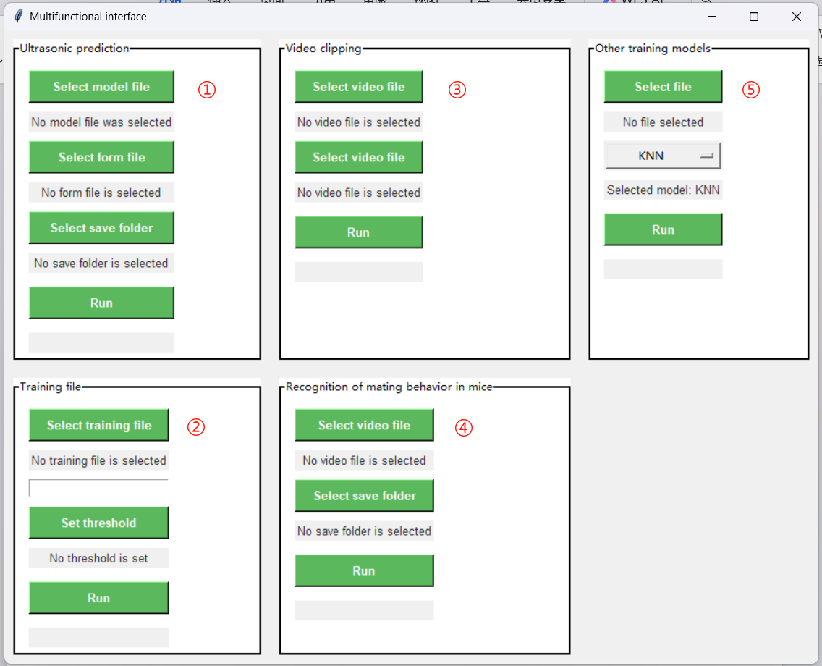

**①: Using ultrasonic model for predict:**

1. Select model file: Select the prediction model in the "\ USV _ data \ model". There are the trained models we provide for mating / non-mating classification models. At the same time, the user can also choose the model trained by himself.
2. Select form file: Select the file to be processed, as the table file in "\ USV _ data \ input": the table file output by deepsqueak, add feature in the last line `interval` is `Begin Time (s) of this line `Begin Time (s) ` minus `End Time (s) `; if you need to train your model, you need to mark the corresponding feature ` y `;
3. Select save folder: Select the run result to store the file, and it is recommended to use "\ USV _ data \ output";
4. Run: move.

**②: Use your own trained ultrasonic model:**

Training your own ultrasonic model can not be limited to the classification model of mating behavior, and users need to annotate their own files for training.

1. Select training file: Select the file used for training, Recommended storage in "" \ USV _ data \ input " Make sure the data file is correctly formed, The ultrasonic table file shall contain the `Call Length (s) `, `Principal Frequency (kHz)`, `Low Freq (kHz)`, `High Freq (kHz)', 'Delta Freq (kHz)', 'Frequency Standard Deviation (kHz)`, `Slope (kHz/s)`, `Sinuosity`, `Mean Power (dB/Hz)`, `Tonality`, `Peak Freq (kHz)`, `interval`, `y`, Where y is the data classification result annotated by the user himself.
2. Set threshold: Select the threshold value of ultrasonic data segmentation. Different situations and different behaviors may be suitable for different thresholds. Users can choose an appropriate threshold value to improve the accuracy of the model. Enter a custom segmentation threshold in the blank box and click Set threshold
3. Run: move.

**③: A convenient video cropping module: used for standardizing the input of the video model.**

1. Select video file: Select the video data to be cropped, and recommend it to store it in "\ video_data \ input";
2. Select save folder: Select the run result to store the file, it is recommended to use "\ video_data \ output";
3. run: move.

Click the four vertices of the detection box in turn, and then press Enter. The program starts to crop and output, the output is the cut video, saved in the selected save folder.

**④: Video model is used for the detection of riding behavior:**

1. Select video file: Select the video data to be predicted and recommend to store it in "\ video_data \ input";
2. Select save folder: Select the run result to store the file, recommend to use "\ video_data \ output"; run the output in three parts, including "Output_minute.txt": mating period in minutes, "Output_s.txt": mating period in seconds, " paragraph XXX. Mp 4 ": sliced video data from the mating period.
3. Run: move.

**⑤: User-selected model training:**

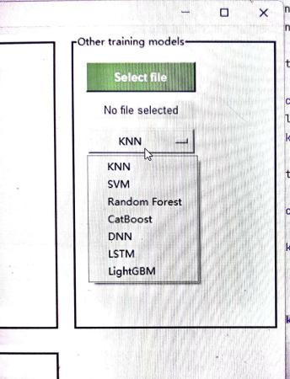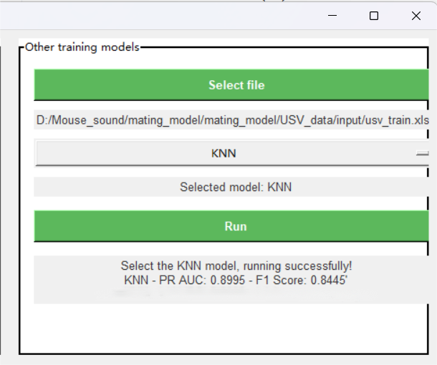

1. Select file: Select the data used for the training, Recommended storage in "\ video_data \ input", Please make sure that the data file is correctly formed, The ultrasonic table file shall contain the `Call Length (s) `, `Principal Frequency (kHz)`, `Low Freq (kHz)`, `High Freq (kHz)', 'Delta Freq (kHz)', 'Frequency Standard Deviation (kHz)`, `Slope (kHz/s)`, `Sinuosity`, `Mean Power (dB/Hz)`, `Tonality`, `Peak Freq (kHz)`, `interval`, `y`, Where y is the data classification result annotated by the user himself.
2. Models selected for training include: KNN, SVM, Random Forest, CatBoost, DNN, LSTM, LightGBM.
3. Run: move. After running, the PR graph and PR AUC and F1 score will be saved.